Extra burden of energy among disabled households

November 2023

Introduction

The cost of living crisis is one of the most challenging in decades. More so for disabled people and their families. Evidence shows the difficult financial situation disabled households are now in. Many already faced material deprivation and significant poverty. The pressures of the last two years have made it impossible for them to afford their needs. Many disabled households are in arrears or have built up debts. Others have rationed the use of their specialist equipment. Or cut back on household essentials. All of these impact negatively on health and wellbeing.

This briefing note sets out the latest data and analyses on how disabled people have been affected during the crisis. And what disabled people expect the impact to be this coming winter (for detail see Appendix A). This includes evidence from:

- Scope-commissioned research from WPI Economics, exploring why disabled people spend a greater proportion of their budget on essentials.

- Scope’s ‘Living with Extra Costs’ research. We conducted qualitative interviews and extra costs homework diaries with 30 disabled households between June and July 2023.

- Scope’s ‘Disability Price Tag 2023’ research which sets out the extra cost of disability.

- Opinium polling survey commissioned by Scope. It looks at disabled people’s finances and concerns this autumn and winter. Surveyed of over 1,000 disabled people, September 2023.

- Statistics from Scope’s Disability Energy Service – our helpline that supports disabled people struggling with energy costs.

- Cost of Living survey completed by over 900 Scope campaigners, September 2023.

- External research sources from charities and academic institutions. An example is the cost of living tracker from the Joseph Rowntree Foundation (JRF).

We also set out Scope’s recommendations on how the Government can support low-income disabled households and those with higher energy usage.

“[Energy prices] have absolutely went through the roof compared to what you were paying before. But with a condition like cerebral palsy, you need to keep warm. So, you've got no real choice.” Arun, 30s, North East England
“I need to use more hot water and stuff like that than [other] people, and in the winter I have to have it at least 21 inside because I can’t cope otherwise sensory wise, so, I can’t turn my thermostat down, it’s got to be at a certain temperature. So whatever the energy price is, I’ve got to pay it, and there are no ifs, buts or maybes in that, it’s got to happen.” Nathaniel, 30s, North West England

Disabled households disadvantaged even before the Cost of Living crisis

The extra costs of disability pre-date this crisis. Life has always been more expensive for disabled people. Scope’s ‘Disability Price Tag’ research finds that on average, disabled households need an additional income of £975 a month. This for them to achieve the same standard of living as non-disabled households. This includes additional spending on:

- specialist disability-related products and services
- needing to spend more on everyday things
- higher usage of essentials.

We know that many socio-economic factors make it harder for disabled people to be resilient in the face of significant financial turbulence. As a result, there is a link between disability and poverty. Half of people in poverty in the UK (50%) are disabled or live with a person who is disabled according to the Poverty Strategy Commission interim report.

The extra cost of disability is not often considered in measures of income poverty. This under reports poverty among disabled people. The Commission’s poverty measure includes the extra costs associated with disability. These extra costs are estimated by the Personal Independence Payments (PIP) or Disability Living Allowance (DLA) benefits received. Scope makes the case for adding over above these payments to compensate for the ‘extra burden’ of essentials for disabled households. As this financial burden tends to be generally higher than the disability benefit payments.

To dig deeper into what is behind the extra cost of disability, Scope commissioned WPI Economics to look at spending on essential items. Understanding these costs, and their impact on the financial security, health and wellbeing of disabled people, is paramount if we are to develop policies to tackle extra costs.

Extra burden of essentials for disabled households
Scope and WPI Economics analysed the Living Costs and Food Survey data from 2017 to 2020. Using different households’ income groups, WPI Economics linked these datasets to the Family Resources Survey 2019 and 2020 data to create a combined dataset.
The research confirmed that disabled households have different spending patterns than non-disabled households. Since the pandemic, prices of essentials have risen more quickly than those of non-essentials. This impacts disabled households more. This is because they devote more of their budget to essentials (including energy) compared to non-disabled households. We have labelled this the ‘extra burden of essentials’, and please see Appendix B for more detail on essentials included. This extra burden facing disabled people means less money left over for other essentials (including additional disability- related extra costs) and discretionary spending.
When comparing disabled households' incomes and spending, and taking into account the price increases of essentials, we found that on average households with a disabled person:

- have lower incomes and spend a greater proportion of their total spending (budget) on essentials such as food and energy.

- would have to spend 31% (£59) more per week in 2023 than they did before the pandemic (assuming that they maintained the same spending patterns throughout). That is equivalent to around £3,068 per year.

- spent 8% of their budget on energy compared to 6% for non-disabled households. This amounts to around £12 extra per week and £634 over the course of a year.

- Among the poorest 20% of the households, disabled households devote more of their budget towards energy: 12% versus 10% for non-disabled households (see Chart 1 below).

Chart 1.

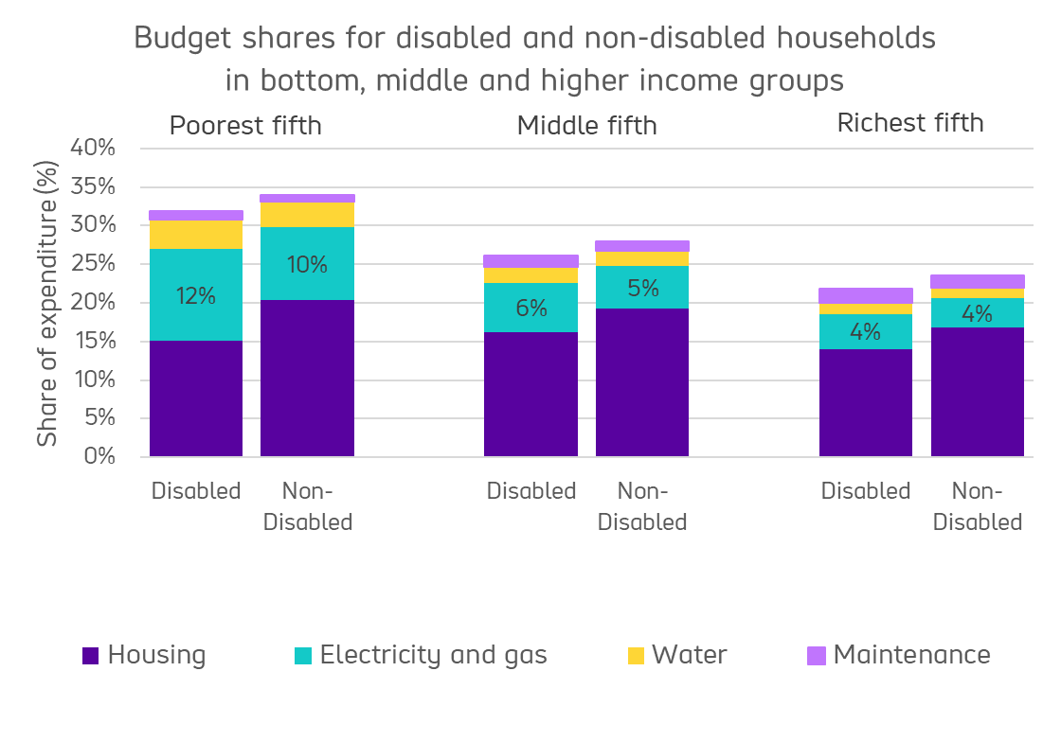
Source: WPI Economics 2023, analysing ONS Living Costs and Food Survey, pooling together 3 years from 2016 and 2017 to 2019 and 2020.
Notes: Housing includes rent and mortgage interest payments

Disabled households disproportionally affected by increased costs of essentials

Soaring inflation, particularly in food and energy prices have hit households hard over the past two years. The current energy price cap of £1,823 per year (down from previous year) remains way above £1,000 which was the average before the war in Ukraine in early 2022.

As energy prices rose, low-income disabled households were hit the hardest. This is because they have to spend more of their budget on energy compared to non-disabled households. Accounting for energy rises in the last three years, the poorest 20% of households face an extra burden of energy of £4.05 per week. The second poorest 20% experienced an extra burden of £5.80 per week. This uprates to £4.70 and £6.70 in 2023 prices. This is money that would otherwise be available to be spent on additional extra costs and discretionary items.
WPI Economics extra burden of energy

Impact of the Cost of Living crisis on household finances

Table 1 summarises the most recent evidence on the impact on disabled households. They experienced more problems with paying rent or mortgage payments than non-disabled households. Disabled households have also built more debt. They are also more likely to be going without essentials (particularly food and energy).

Impact of the Cost-of-Living crisis on health and wellbeing

Scope’s Living with Extra Costs interviews explored the links between energy usage and disabled people’s health. Many disabled people need more electricity for disability specific equipment. Others need the heating at a constant temperature to manage pain. Energy use needs mean higher costs when an impairment or condition worsens.
Similarly, our Scope supporter survey (September 2023) asked what steps over 900 disabled people are considering taking this winter, if no further financial support materialises. Worryingly it showed:

- 21% may have to go without essential medication and treatment
- 18% may need to stop using electrical equipment, such as stairlifts and hoists
- 8% may have to sell mobility equipment such as scooters.

“I'm freezing cold in winter. I get so stiff, so much pain, […] when I get too cold, it can trigger an adrenal crisis. This is the life-threatening situation, where I have to inject steroids and I had to do that twice." Charlie, 50s, South East England
“I suffer with skin rashes and lots of skin conditions and infections and all that kind of stuff, especially in the summer. So, I wash my clothes more regularly than most people and it's keeping me healthy, which is great. I think we do the laundry about seven times a week”. Robin, 30s, South East England
“I spent my winter without heating […] but I was so cold I didn't realise that when they say if you're disabled you should have your temperatures at nineteen degrees, there's a reason. Sixteen degrees is my favourite temperature, you can put on a jumper, you're still comfortable. Thirteen degrees you get respiratory problems. Eleven degrees your brain starts to, kind of, shut down and you think really stupid things. […] my brain at eleven degrees was not functioning at all.” Hanna, 40s, Wales

"You know, basic things like dentist appointments - I haven't been in years and we're looking at [the cost of] them now and then you think, 'Oh, I think I'll have to push that back another month.'" Liane, 30s, South West England

The Glasgow Centre for Population Health and the Glasgow Disability Alliance found that disabled drivers used their vehicle less as fuel costs went up. For some this resulted in missed medical appointments. Among those with limited finances, it damaged their social connections.

“My car is my independence, it’s my lifeline to the outside world,
without it I am housebound. I’ve had a good few times recently where I cannot use the car, it’s had no petrol in it and I’ve been you know, like 10 days before I get my PIP – so it’s just sat there and I’ve been sitting there as well, doing nothing, no social interaction, nothing.”
COPH GDA research participant

Outlook for disabled households

National Energy Action (NEA) estimated that energy bills will be 13% higher compared to last winter. This is due to the absence of the £400 discount on energy bills seen last year.

Scope calculated average energy bills by different income groups. Disabled households have higher energy bills than non-disabled households. This energy costs gap is particularly large among low-income groups.

Using energy price forecasts for the first calendar quarter in 2024, we estimated energy bills for 2023 and 2024. We then compared these costs against energy bills in 2021 and 2022. The costs of energy bills for the poorest 20% of households are expected to increase significantly by around 45% in this financial year (2023 and 2024).

Disabled people are struggling. A Scope’s supporters survey asked if the Government is giving them enough help this winter. From the results, overwhelmingly most disabled people do not think the Government is supporting them.

Do you think the government is doing enough to support disabled people with the extra costs of energy this autumn and winter?

Nowhere near | 766 | 82.63%
Not quite | 127 | 13.70%
Don't know | 18 | 1.94%
Just about | 12 | 1.29%
More than | 4 | 0.43%

“…Energy companies are intentionally making it difficult for you to choose the best [deals]…Why is there no social tariff within the energy companies? […] Why are pre-paid meters charged more than people on direct debit? Because the people on direct debit can afford their energy. I feel the energy companies and energy crisis are definitely taking advantage of the less well off.” Hanna, 40s, Wales

We welcome the cost of living payments and other financial supports in the last two years. Yet, they have not met the needs of disabled households.

The Resolution Foundation also notes that living costs payments have not been enough. Linking eligibility of living costs payments to only those who get benefits led to many households missing out. An estimated 2.3 million households do not receive means-tested benefits. These are the poorest 20% of households. Many disabled households are among them.

Add in the backdrop of diminishing savings and increasing levels of debt following pressure since the pandemic. And with energy bills double the levels before the war in Ukraine. The Government must better target support for disabled households who need it most.

Recommendations

Our recommendations for government are:

Short term (winter 2023/2024)
- Urgently launch the promised government consultation on an energy social tariff.

- Expand the eligibility criteria for the £300 cost of living payments so that disabled households in receipt of contribution based or new style ESA are eligible.

- Deliver an additional disability cost of living payment of £150 to people in receipt non-means tested benefits.

Medium Term (In time for winter 2024/2025)
- Reinstate the Warm Home Discount for the 300,000 disabled people who lost this vital support due to changes in eligibility criteria. This includes people in receipt of legacy benefits and people who receive Personal Independence Payments (PIP).

- Ban of forced installations of prepayment meter (PPM)’s for all disabled households. Explore a PPM amnesty. So that disabled households with a PPM have the opportunity to have it uninstalled and to receive adequate compensation.

- Extend the Energy Price Guarantee for disabled households beyond March 2024, until a social tariff is introduced.

Longer term
- Introduce a government-funded energy social tariff for disabled households.

Appendices

Appendix A: Scope’s analysis or commissioned work

WPI Economics: analysis of extra burden of essentials
Scope commissioned WPI Economics to investigate the extra burden of essentials which disabled households face. This analysis explores how differences in household spending are affected by the presence of disabled individuals in the household.

Living with Extra Costs: qualitative research and diary study
Scope complemented this analysis by collecting a weekly household costs diary of disabled households. The diary covered a range of essential spending and extra disability-related costs. Interviews were also conducted with a disabled member or representative of the household. This helps to understand their experiences of financial decision-making and managing their household finances at the current time. And how this position impacts on their families’ health and wellbeing.

Opinium: ‘Winter Concerns’ survey of 1,017 disabled people
Scope’s recent ‘Winter Concerns’ survey focussed on the experiences and concerns of disabled households on managing through this coming winter.

Disability Energy Service activity
Statistics from our Disability Energy Service – a helpline and advice service. This supports disabled people struggling with energy costs. The information covers the period of September 2023.

Scope supporters survey
Online survey of 927 Scope campaigners (September 2023), exploring cost of living crisis issues and the impact on disabled households. Note that not all respondents answered all questions. This means for some questions will have under 927 respondents.

Disability Price Tag 2023
In calculating the latest Disability Price Tag figure, we used a Standard of Living approach consistent with our previous research.
In 2023, we looked at survey data from 2019 and 2020. It showed how much extra money families with disabled members need. This estimated the additional income disabled households would require balancing out the extra cost of disability.

This includes areas of expenditure to pay for their additional spending on:

- Specialist disability-related products and services: These are essential and often costly. They include things like vital specialist equipment, mobility aids, car or home adaptations, medicines, and therapies. These are all expensive.

- Needing to spend more on everyday things: Booking a holiday may lead to extra costs due to a lack of availability of accessible rooms. Limited mobility may mean needing to buy more expensive ready meals or rely on the delivery of household goods more.

- Higher usage of essentials: Many disabled households need to use more energy or may need additional accessible transport options.

Appendix B: List of essential products and services

Essentials are products or services required by a consumer to sustain health or life. WPI Economics followed the classification by the Australian Bureau of Statistics (ABS). This helps to identify items as essential or non-essential. It has the advantage that looks at a more granular level of essential items.

ABS classification does not map to the Classification of Individual Consumption According to Purpose (COICOP) categories. As most of the latter contain a mix of essential and non-essential items.

For example, all basic food items in the 01 Food and non-alcoholic beverages are considered essential. While cakes and confectionery in the same overall category 01 are considered non-essential. The exception is 04 Housing and 06 Health. All items in those categories are considered essential.

COICOP categories used in WPI Economics and Scope analysis.
01 Food and non-alcoholic beverages | 7 Transport excluding private car hire (taxis etc.)
02 Alcoholic beverages, tobacco and narcotics | 7.3.5 Taxis and hired cars with drivers
03 Clothing and footwear | 08 Communication
4 Housing excluding energy bills | 09 Recreation and culture
4.5 Energy bills | 10 Education
05 Furnishings, household equipment and routine household maintenance | 11 Restaurants and hotels
06 Health | 12 Miscellaneous goods and services

Appendix C: Costing and options for introducing a social tariff
A social tariff is defined as a reduced tariff, at a certain discount for certain goods or services, to make them affordable to low-income or disadvantaged groups.

The cost of any such social tariff has three areas which need to be decided:

1) Who receives the social tariff.

All disabled people under the core definition
Disabled people who receive disability related benefits
Disabled people who receive disability and income related benefits

2) How much is the payment worth

A fixed payment
A percentage of the energy price cap
A bigger discount on standing charges which benefits low energy users, or a discount based on megawatt hours (MWhs), the charge per unit of electricity, which benefits more intensive energy users.

3) Who pays for it?

Government funded from taxes.
Funded through mechanisms such as a windfall tax, passing laws to obligate energy companies to provide it
Combination of Government and energy companies
Provided like the warm home discount. Those who do not receive the discount fund the discount.
The answers to these questions are not yet known but in each of these it would impact the total costs. The costings and options of implementation of a social tariff will be investigated, but these were beyond the scope of this briefing note.

Endnotes

Disability Price Tag Technical Report 2023. From all households we identify as a disabled households if at least one adult self- reported as disabled (experiencing a health condition or disability over the 12 months and has affected negatively their daily activities.
Poverty strategy commission 2023 ‘A new framework for tacking poverty’ https://povertystrategycommission.org.uk/wp-content/uploads/2023/09/PSC-Framework-Report-230831-Web.pdf
Using the annual CPI inflation between the financial years 2019 and 2022, which was 15%, we uprated the corresponding £4.05 and £5.80 per weekly payments.
Glasgow Centre for Population Health 2023 ‘The impacts of the cost-of-living crisis on disabled people: a case for action’. Focus groups conducted in Glasgow with Glasgow Disability Alliance https://www.gcph.co.uk/assets/0000/9844/CoL_Disabled_people.pdf
NEA noted that from October 2022 to March 2023, the government’s Energy Price Guarantee set average bills at £2,500 per year, or £208 per month. As each household received £67 per month from the Energy Bill Support Scheme over this period, the average monthly cost of energy was £141. This year, unless further support is announced, average costs in the period from October to December 2023 will come to £160.
Scope estimated average bills based on the Living Costs and Food Survey 2019/2020 data, information from Ofgem spreadsheet model default tariff cap levels https://www.ofgem.gov.uk/publications/energy-price-cap-default-tariff-1-october-31-december-2023 and Cornwall Insight forecasts of energy prices.
Resolution Foundation 2023 ‘Gotta get through this’ https://www.resolutionfoundation.org/publications/gotta-get-through-this/
WPI Economics consultants undertook quantitative analysis on the actual spending across households. They estimated the differences in day-to-day spending patterns for people with similar levels of income. Their analysis accounted for socioeconomic and demographic characteristics of the households. Disability status was considered when there was at least one disabled adult in the household. The model included a variable to identify whether a member of the household was claiming disability benefits (PIP or DLA or AA) or other means tested benefits with a disability component.
Scope’s ‘Living with the extra costs of disability’ study was conducted in 2023. As part of this, one member of 31 households with at least one disabled people completed a weekly homework diary, over a period of three weeks. The diary collated weekly costs on items, goods and services which were both disability- and non-disability related. Following the diary exercise, 30 individuals then completed an online in-depth interview, in which they were asked to reflect on the emotional impact of the extra costs of being disabled.
Opinium Research conducted the Scope ‘Winter Concerns’ research survey with 1,017 disabled adults in England and Wales during 13th - 20th September 2023.
We wanted to identify the difference between families with disabled members and those without. We looked at whether families can afford to buy important things or do important tasks. For example, buying insurance, fixing broken items, having some money to spend each week, and saving a bit. We also considered where they live, and how much they earn including disability benefits payments. We believe this money difference is because of the costs linked to having a disability.

